Identification
Name: |  | Notebook reference: |  |  |  |  |  |  |  | Date:
Reaction description Please describe the reaction (or provide a reaction scheme)
Previous experience If the exact same reaction on the same or larger scale has been approved, this reaction is also. If an incident has happened previously, consider it in a new risk analysis.
Experience: ☐ I have done this exact reaction before Notebook reference:
Scale: ☐ Same / smaller ☐ larger
Risks: Are the risks the same? ☐Yes ☐ No
Chemical Products Identify the chemical products, their risks, and risk levels for all products used in the reaction
Product No.  3  4  5 | Product Name |  | Quantity  (g, mg, kg, ml, L) | Possible Risks |  |  |  |  |  |  |  |  |  | Risk level  (0-5) |  | Have manipulated the product before
 |  |  |  | 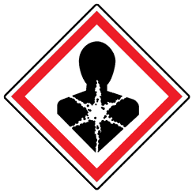  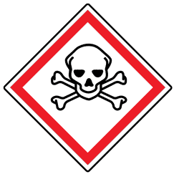  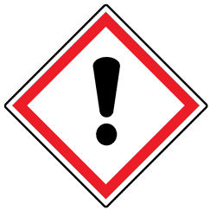  Toxic | 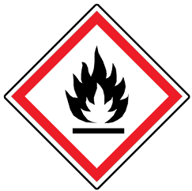  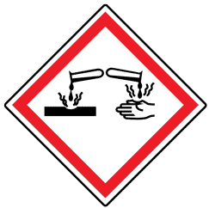  Corrosive | Flammable | 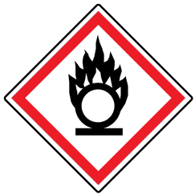  Oxidizer | 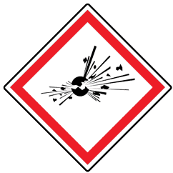  Explosive | 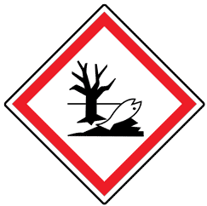  Enviro. Haz. |  | 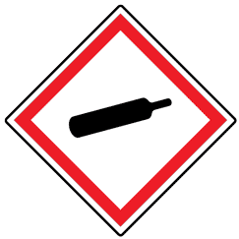  Comp. Gas | Other:___________
1. |  |  |  | ☐ | ☐ | ☐ | ☐ | ☐ | ☐ |  | ☐ | ☐ |  |  |  | ☐
2. |  |  |  | ☐ | ☐ | ☐ | ☐ | ☐ | ☐ |  | ☐ | ☐ |  |  |  | ☐
3. |  |  |  | ☐ | ☐ | ☐ | ☐ | ☐ | ☐ |  | ☐ | ☐ |  |  |  | ☐
4. |  |  |  | ☐ | ☐ | ☐ | ☐ | ☐ | ☐ |  | ☐ | ☐ |  |  |  | ☐
5. |  |  |  | ☐ | ☐ | ☐ | ☐ | ☐ | ☐ |  | ☐ | ☐ |  |  |  | ☐
6. |  |  |  | ☐ | ☐ | ☐ | ☐ | ☐ | ☐ |  | ☐ | ☐ |  |  |  | ☐
7. |  |  |  | ☐ | ☐ | ☐ | ☐ | ☐ | ☐ |  | ☐ | ☐ |  |  |  | ☐
8. |  |  |  | ☐ | ☐ | ☐ | ☐ | ☐ | ☐ |  | ☐ | ☐ |  |  |  | ☐
9. |  |  |  | ☐ | ☐ | ☐ | ☐ | ☐ | ☐ |  | ☐ | ☐ |  |  |  | ☐
10. |  |  |  | ☐ | ☐ | ☐ | ☐ | ☐ | ☐ |  | ☐ | ☐ |  |  |  | ☐
11. |  |  |  | ☐ | ☐ | ☐ | ☐ | ☐ | ☐ |  | ☐ | ☐ |  |  |  | ☐
12. |  |  |  | ☐ | ☐ | ☐ | ☐ | ☐ | ☐ |  | ☐ | ☐ |  |  |  | ☐
13. |  |  |  | ☐ | ☐ | ☐ | ☐ | ☐ | ☐ |  | ☐ | ☐ |  |  |  | ☐
14. |  |  |  | ☐ | ☐ | ☐ | ☐ | ☐ | ☐ |  | ☐ | ☐ |  |  |  | ☐
15. |  |  |  | ☐ | ☐ | ☐ | ☐ | ☐ | ☐ |  | ☐ | ☐ |  |  |  | ☐
Minimum risk levels: + 2, + 1, + 1, + 2, (b.p < 60°C) + 2, (b.p > 60°C) + 1, + 1, + 5,
+ 1, + 1. Other (Highly Reactive, Pyrophoric, Carcinogen, etc.) = Risk +1
Total (Max = No. of products x 5) Note: Products with No Risk are not counted in the Max value |  |  |  |  |  |  |  |  |  |  |  |  |  |  | /

Reaction Conditions
Thermal Conditions |  |  |  |  |  |  |  |  |  |  |  |  |  |  | Risk level (0-5)
☐ Room Temperature 20°C (Risk + 0)
☐ Heating (Risk +1) ☐ 20 to 60°C (Risk + 2) ☐60 to 100°C (Risk + 3)
☐ 100 to 150°C (Risk + 4) ☐150 to 200°C and more (Risk + 5)
☐ Cooling (Risk + 1) ☐ 20 to - 15°C (Risk + 2) ☐-15 to -50°C (Risk + 3)
☐ -50 to -100°C (Risk + 4) ☐-100 to -150°C and more (Risk + 5)
Note: Dangers of the solvent used for the cooling bath must be indicated in the Chemical Products
Atmospheric Conditions |  |  |  |  |  |  |  |  |  |  |  |  |  |  | Risk level (0-5)
☐Air / open flask (Risk + 0)
☐Gas at 1atm (Risk + 1) ☐ 1 to 2 atm (Risk + 2) ☐2 to 5 atm (Risk + 3)
☐ Ar / N₂ ☐ 5 to 7 atm (Risk + 4) ☐10 atm and more (Risk + 5)
☐ Other _________________ Note: Dangers of this gas must be indicated in the Chemical Products
☐Low vacuum (Risk level + 1) ☐ High vacuum (Risk level + 3)
Quench |  |  |  |  |  |  |  |  |  |  |  |  |  |  | Risk level (0-2)
Do you need to quench your reaction? ☐Yes (Risk + 1) ☐No
If yes, is your quench exothermic? ☐Yes (Risk +1) ☐No
Total (Max = 0, 5 or 10 ) |  |  |  |  |  |  |  |  |  |  |  |  |  |  |  | /
Risk Evaluation
Total Risk Level (risk levels exceeding 50% must be approved by supervisor) |  |  |  |  |  |  |  |  |  |  |  |  |  |  |  | /
Personal Protection Equipment Required
 |  |  |  |  |  | ☐ Nitrile
☐ |  | ☐ |  | ☐ |  | ☐ Rubber |  | ☐ |  | ☐ |  | ☐ |  | ☐ Other : _________________
 |  |  |  |  |  | ☐ Latex
Anticipated Work-up and Purification
Work-up Methods
☐ Water / brine wash Drying Agent ___________
☐ Acid / base wash Concentration __________ Drying Agent ___________
☐ Filtration ☐ Gravity ☐ Suction
☐ Evaporation
☐ Other Specify: _______________
I have read the Standard Operating Procedure for all of the checked work-up methods? ☐Yes ☐ No
Purification Methods
☐ Column chromatography ☐ Gravity ☐ Under pressure
☐ Recrystallization
☐ Distillation ☐ Simple ☐ Reduced pressure
☐ Sublimation ☐ Simple ☐ Reduced pressure
☐ Other Specify: _______________
I have read the Standard Operating Procedure for all of the checked purification methods? ☐Yes ☐ No
Additional Comments (from the experimenter)
Approval (if necessary)
Approval Options |  |  |  |  |  |  | ☐ Risk levels are well controlled, the reaction can be completed.  ☐ Risk levels are elevated, recommend completing full risk analysis.  ☐ Risk levels are too high, this reaction cannot be done.
Additional Comments (from the supervisor)
Supervisor’s signature:

