Identification
Name: |  | Notebook reference: |  |  |  |  |  |  |  | Date:
Reaction description Please describe the reaction (or provide a reaction scheme)
Previous experience If the exact same reaction on the same or smaller scale has been approved this reaction is also.
Experience: ☐ I have done this exact reaction before Notebook reference:
Scale: ☐ Same / smaller ☐ larger
Risks: Are the risks the same? ☐Yes ☐ No
Chemical Products Identify the chemical products, their risks, and risk levels for all products used in the reaction
Product No.  3  4  5 | Product Name |  | Quantity  (g, mg, kg, ml, L) | Possible Risks |  |  |  |  |  |  |  |  |  | Risk level  (0-5) |  | Have manipulated the product before
 |  |  |  | 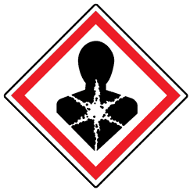  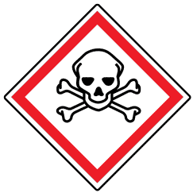  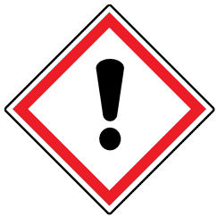  Toxic | 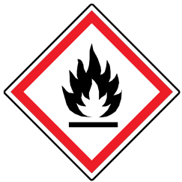  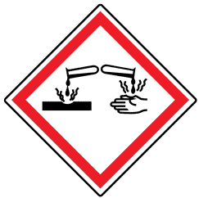  Corrosive | Flammable | 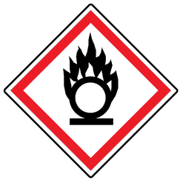  Oxidizer | 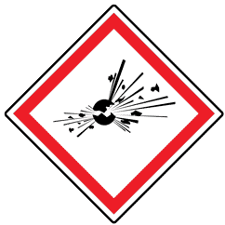  Explosive | 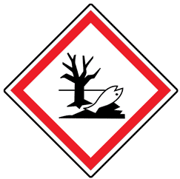  Enviro. Haz. |  | 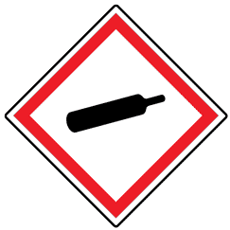  Comp. Gas | Other:___________
1. |  |  |  | ☐ | ☐ | ☐ | ☐ | ☐ | ☐ |  | ☐ | ☐ |  |  |  | ☐
2. |  |  |  | ☐ | ☐ | ☐ | ☐ | ☐ | ☐ |  | ☐ | ☐ |  |  |  | ☐
3. |  |  |  | ☐ | ☐ | ☐ | ☐ | ☐ | ☐ |  | ☐ | ☐ |  |  |  | ☐
4. |  |  |  | ☐ | ☐ | ☐ | ☐ | ☐ | ☐ |  | ☐ | ☐ |  |  |  | ☐
5. |  |  |  | ☐ | ☐ | ☐ | ☐ | ☐ | ☐ |  | ☐ | ☐ |  |  |  | ☐
6. |  |  |  | ☐ | ☐ | ☐ | ☐ | ☐ | ☐ |  | ☐ | ☐ |  |  |  | ☐
7. |  |  |  | ☐ | ☐ | ☐ | ☐ | ☐ | ☐ |  | ☐ | ☐ |  |  |  | ☐
8. |  |  |  | ☐ | ☐ | ☐ | ☐ | ☐ | ☐ |  | ☐ | ☐ |  |  |  | ☐
9. |  |  |  | ☐ | ☐ | ☐ | ☐ | ☐ | ☐ |  | ☐ | ☐ |  |  |  | ☐
10. |  |  |  | ☐ | ☐ | ☐ | ☐ | ☐ | ☐ |  | ☐ | ☐ |  |  |  | ☐
11. |  |  |  | ☐ | ☐ | ☐ | ☐ | ☐ | ☐ |  | ☐ | ☐ |  |  |  | ☐
12. |  |  |  | ☐ | ☐ | ☐ | ☐ | ☐ | ☐ |  | ☐ | ☐ |  |  |  | ☐
13. |  |  |  | ☐ | ☐ | ☐ | ☐ | ☐ | ☐ |  | ☐ | ☐ |  |  |  | ☐
14. |  |  |  | ☐ | ☐ | ☐ | ☐ | ☐ | ☐ |  | ☐ | ☐ |  |  |  | ☐
15. |  |  |  | ☐ | ☐ | ☐ | ☐ | ☐ | ☐ |  | ☐ | ☐ |  |  |  | ☐
Minimum risk levels: + 2, + 1, + 1, + 2, (b.p < 60°C) + 2, (b.p > 60°C) + 1, + 1, + 5,
+ 1, + 1. Other (Highly Reactive, Pyrophoric, Carcinogen, etc.) = Risk +1
Total (Max = No. of products x 5) Note: Products with No Risk are not counted in the Max value |  |  |  |  |  |  |  |  |  |  |  |  |  |  | /

Reaction Conditions
Thermal Conditions |  |  |  |  |  |  |  |  |  |  |  |  |  |  | Risk level (0-5)
☐ Room Temperature 20°C (Risk + 0)
☐ Heating (Risk +1) ☐ 20 to 60°C (Risk + 2) ☐60 to 100°C (Risk + 3)
☐ 100 to 150°C (Risk + 4) ☐150 to 200°C and more (Risk + 5)
☐ Cooling (Risk + 1) ☐ 20 to - 15°C (Risk + 2) ☐-15 to -50°C (Risk + 3)
☐ -50 to -100°C (Risk + 4) ☐-100 to -150°C and more (Risk + 5)
Note: Dangers of the solvent used for the cooling bath must be indicated in the Chemical Products
Atmospheric Conditions |  |  |  |  |  |  |  |  |  |  |  |  |  |  | Risk level (0-5)
☐Air / open flask (Risk + 0)
☐Gas at 1atm (Risk + 1) ☐ 1 to 2 atm (Risk + 2) ☐2 to 5 atm (Risk + 3)
☐ Ar / N₂ ☐ 5 to 7 atm (Risk + 4) ☐10 atm and more (Risk + 5)
☐ Other _________________ Note: Dangers of this gas must be indicated in the Chemical Products
☐Low vacuum (Risk level + 1) ☐ High vacuum (Risk level + 3)
Quench |  |  |  |  |  |  |  |  |  |  |  |  |  |  | Risk level (0-2)
Do you need to quench your reaction? ☐Yes (Risk + 1) ☐No
If yes, is your quench exothermic? ☐Yes (Risk +1) ☐No
Total (Max = 0, 5 or 10 ) |  |  |  |  |  |  |  |  |  |  |  |  |  |  |  | /
Risk Evaluation
Total Risk Level (risk levels exceeding 50% must be approved by supervisor) |  |  |  |  |  |  |  |  |  |  |  |  |  |  |  | /
Personal Protection Equipment Required
 |  |  |  |  |  | ☐ Nitrile
☐ |  | ☐ |  | ☐ |  | ☐ Rubber |  | ☐ |  | ☐ |  | ☐ |  | ☐ Other : _________________
 |  |  |  |  |  | ☐ Latex
Anticipated Work-up and Purification
Work-up Methods
☐ Water / brine wash Drying Agent ___________
☐ Acid / base wash Concentration __________ Drying Agent ___________
☐ Filtration ☐ Gravity ☐ Suction
☐ Evaporation
☐ Other Specify: _______________
I have read the Standard Operating Procedure for all of the checked work-up methods? ☐Yes ☐ No
Purification Methods
☐ Column chromatography ☐ Gravity ☐ Under pressure
☐ Recrystallization
☐ Distillation ☐ Simple ☐ Reduced pressure
☐ Sublimation ☐ Simple ☐ Reduced pressure
☐ Other Specify: _______________
I have read the Standard Operating Procedure for all of the checked purification methods? ☐Yes ☐ No
Additional Comments (from the experimenter)
Approval (if necessary)
Approval Options |  |  |  |  |  |  | ☐ Risk levels are well controlled, the reaction can be completed.  ☐ Risk levels are elevated, recommend completing full risk analysis.  ☐ Risk levels are too high, this reaction cannot be done.
Additional Comments (from the supervisor)
Supervisor’s signature:

